Hybrid Energy Harvesting System Using Train-Induced Vibration And Airflow In Railway Tunnels

by
DHANUSH S | 2311030
SATHISH KUMAR V | 2311112
AROCKYA ABINESH A | 2311123

23EC64C-PRODUCT DEVELOPMENT PRACTICE
in partial fulfillment of the requirements for the degree of

BACHELOR OF ENGINEERING IN

ELECTRONICS AND COMMUNICATION

ANNA UNIVERSITY, CHENNAI


NATIONAL ENGINEERING COLLEGE , KOVILPATTI (AN AUTONOMOUS INSTITUTION)

APRIL 2026
BONAFIDE CERTIFICATE
SUPERVISOR | HEAD OF THE DEPARTMENT
Mrs. Kirthiga @ Sridevi M.E., | Dr.S.Tamil Selvi M.E., Ph.D.,
Assistant Professor | Professor & Head
Department of ECE | Department of ECE
National Engineering College, | National Engineering College,
K.R.Nagar, Kovilpatti -628 503 | K.R.Nagar, Kovilpatti -628 503
Certified that this project report titled “Hybrid Energy Harvesting System Using Train-Induced Vibration And Airflow In Railway Tunnels” is the bonafide work of, Dhanush S (2311030), Sathish Kumar V (2311112), Arockya Abinesh A (2311123), who carried out the project under my supervision for the partial fulfilment of the requirements for the award of the degree of Bachelor of Engineering in ELECTRONICS AND COMMUNICATION Certified further, that to the best of my knowledge the work reported here does not form part of any other project report or dissertation on the basis of which a degree or award was conferred on an earlier occasion on this or any other candidate.

SIGNATURE SIGNATURE

Submitted to 23EC64C- Product Development Practice viva voce examination held on _________________

Place: K.R.Nagar,Kovilpatti
Date:

INTERNAL EXAMINER | EXTERNAL EXAMINER
ACKNOWLEDGEMENT

First and foremost, we would like to thank God Almighty for showering his blessings throughout our life. He has been the tower of our strength in each step of my work. We take the privilege to express hearty thanks to my parents for their valuable support and effort to complete the project work.
We would like to express our deep sense of gratitude and respectful regards to our Director Dr. S. Shanmugavel B.Sc., D.M.I.T., Ph.D., for giving an opportunity to do this work.
Having Gratitude is conveyed towards our highly respected the Principal, Dr. K. Kalidasa Murugavel, M.E., Ph.D., for providing unwavering support for our endeavor.
We would like to send our sincere gratitude to our esteemed Department Head, Dr.S Tamil Selvi M.E., Ph.D., Department of Electronics and Communication Engineering, for her unwavering support and provision of several facilities during the project.
We would like to take this opportunity to acknowledge my generous Project Mentor Mrs. Kirthiga @ Sridevi M.E., Assistant Professor, Department of Electronics and Communication Engineering, for her insightful advice, helpful recommendations and technical support throughout the project.
We extend my sincere gratitude to Mr.B.Ganapathy Ram M.E., Assistant Professor(Sr.Gr) and Mrs.S.Karthika M.E., Assistant professor, Department of Electronics and Communication Engineering, they have been my Project Coordinators and have provided invaluable assistance throughout the entire project. We would also like to thank my tutor, class instructor, faculty members, non-teaching staff and friends for their valuable advice, recommendations and collaboration during our project work.

TABLE OF CONTENTS
CHAPTER NO. | TITLE | PAGE NO.
1 | Abstract | 6
 | Outcome of the Literature Search | 6
 | XLScout search result feedback: | 6
 | Attorney Feedback on the Literature Search | 6
2 | - Technology Domain of the Invention | 7
 | - Industrial Problem(s) Identified | 7
 | - Solution(s) already available to solve the aforesaid problem(s) | 7
 | - Drawbacks of the aforesaid solutions | 7
 | - Objective(s) of the Project | 8
3 | VI. Architecture Diagram | 9
 | - Block Diagram | 9
 | - Circuit diagram | 10
 | - List of Reference Numerals | 11
 | - A detailed explanation, on the constructional features  - Working of the Invention (Explanation of Features, Software, Parameters) | 12
 | VIII. A detailed explanation, on the Invention's Software portion | 16
4 | IX. A detailed, step-by-step explanation, on how the Invention functions with reference to the constructional features, threshold values and Flowcharts | 17
 | - Calculations | 19
 | - Details of tests conducted | 20
 | - Characterisation Tests, Comparative Results, and Inferences | 23
5 | XIII. Examples that illustrate real-time functioning of the Invention, in different scenarios | 24
 | XIV. A list of all advantages of the Invention and how the Invention overcomes the drawbacks of the existing solutions | 24
 | XV. Possible future enhancements to the invention, | 25
6 | XVI. Concluding Summary | 26
 | References | 26

LIST OF FIGURES
FIGURE NO. | FIGURE NAME | PAGE NO.
3.1 | Block Diagram of Hybrid Energy Harvesting System | 9
3.2 | Circuit Diagram of Proposed System | 10

LIST OF TABLES
TABLE NO. | TABLE NAME | PAGE NO.
3.1 | Reference Numerals | 11
4.1 | Results | 23

Chapter 1
Title: Hybrid Energy Harvesting System Using Train-Induced Vibration And Airflow In Railway Tunnels
Abstract:
The proposed system presents a hybrid energy harvesting solution designed for railway tunnels by utilizing two untapped energy sources: train-induced vibration and airflow. Piezoelectric sensors are used to convert mechanical vibrations generated by passing trains into electrical energy, while a micro turbine captures kinetic energy from airflow inside tunnels. The generated AC energy is converted into DC using bridge rectifiers and stored in capacitors and rechargeable lithium-ion batteries through a TP4056 charging module. An Arduino-based control system monitors voltage levels and controls tunnel lighting and alert systems. This system reduces dependency on conventional power sources and enhances safety by providing reliable lighting inside tunnels. The proposed solution is energy-efficient, cost-effective, and supports sustainable railway infrastructure development. It also aligns with smart transportation systems and renewable energy utilization.
Is a Literature Search Conducted through Novelty checker: Yes
Outcome of the Literature Search:
Based on novelty report ,similar systems exist but:
- Not tunnel-specific
- Not hybrid optimized
- Lack monitoring integration
Attorney Feedback on the Literature Search (Mentioned during the first review by attorney):
- Patent Attorney: Detailed study about the technology to be adopted has to be done
- Dr.V.Lingasamy, Manager (R&D), Rakuten Mobiles : Usage scenario, CAPEX/OPEX analysis
- Mr.B.Joben, Hardware Design Engineer, Mistral Solutions : select suitable design for fan blade (use light weight materials), add some images of tunnel from research paper

Chapter 2
- Technology Domain of the Invention:
The invention belongs to renewable energy harvesting systems, embedded systems, and smart railway infrastructure. It integrates piezoelectric sensing, airflow energy generation, power electronics, and microcontroller-based monitoring for sustainable energy generation and utilization in railway tunnels.

- Industrial Problem(s) Identified:
- Lack of reliable tunnel lighting
- High electricity consumption
- Power failures
- Wasted mechanical energy
- High maintenance cost

- Solution(s) already available to solve the aforesaid problem(s):
- Footsteps to Electricity in Japan
- Advanced Multi-Source Energy Harvesting And Distribution System
- Ai-Based Tunnel Management System With Low Energy Consumption

- Drawbacks of the aforesaid solutions
1) Footsteps to Electricity (Japan)
- Generates very low power output, insufficient for large-scale applications like tunnel lighting
- Works only in high human traffic areas, not suitable for railway tunnels
- High installation cost due to special flooring systems
- Energy generation is inconsistent and unpredictable
2) Advanced Multi-Source Energy Harvesting and Distribution System
- Complex system design, making implementation difficult in real environments
- Requires high initial investment and sophisticated control systems
- Not specifically designed for railway tunnel conditions
- Maintenance and integration challenges with existing infrastructure
3) AI-Based Tunnel Management System with Low Energy Consumption
- Primarily focuses on energy management, not energy generation
- Still depends on external power supply
- High computational cost due to AI processing
- Requires continuous data and network connectivity, increasing system complexity

- Objective(s) of the Project:
• Harvest vibration + airflow energy
• Store energy efficiently
• Provide self-powered lighting
• Reduce electricity cost
• Improve tunnel safety

Chapter 3
- Figures (block Diagram, Circuit Diagram, GeoTagged Photos):
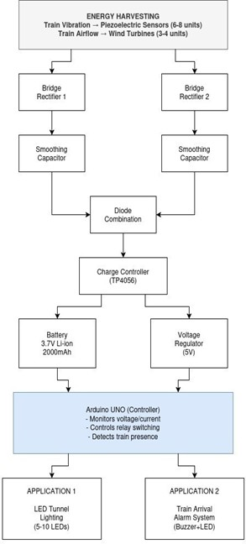
Fig 3.1: Block Diagram of Hybrid Energy Harvesting System
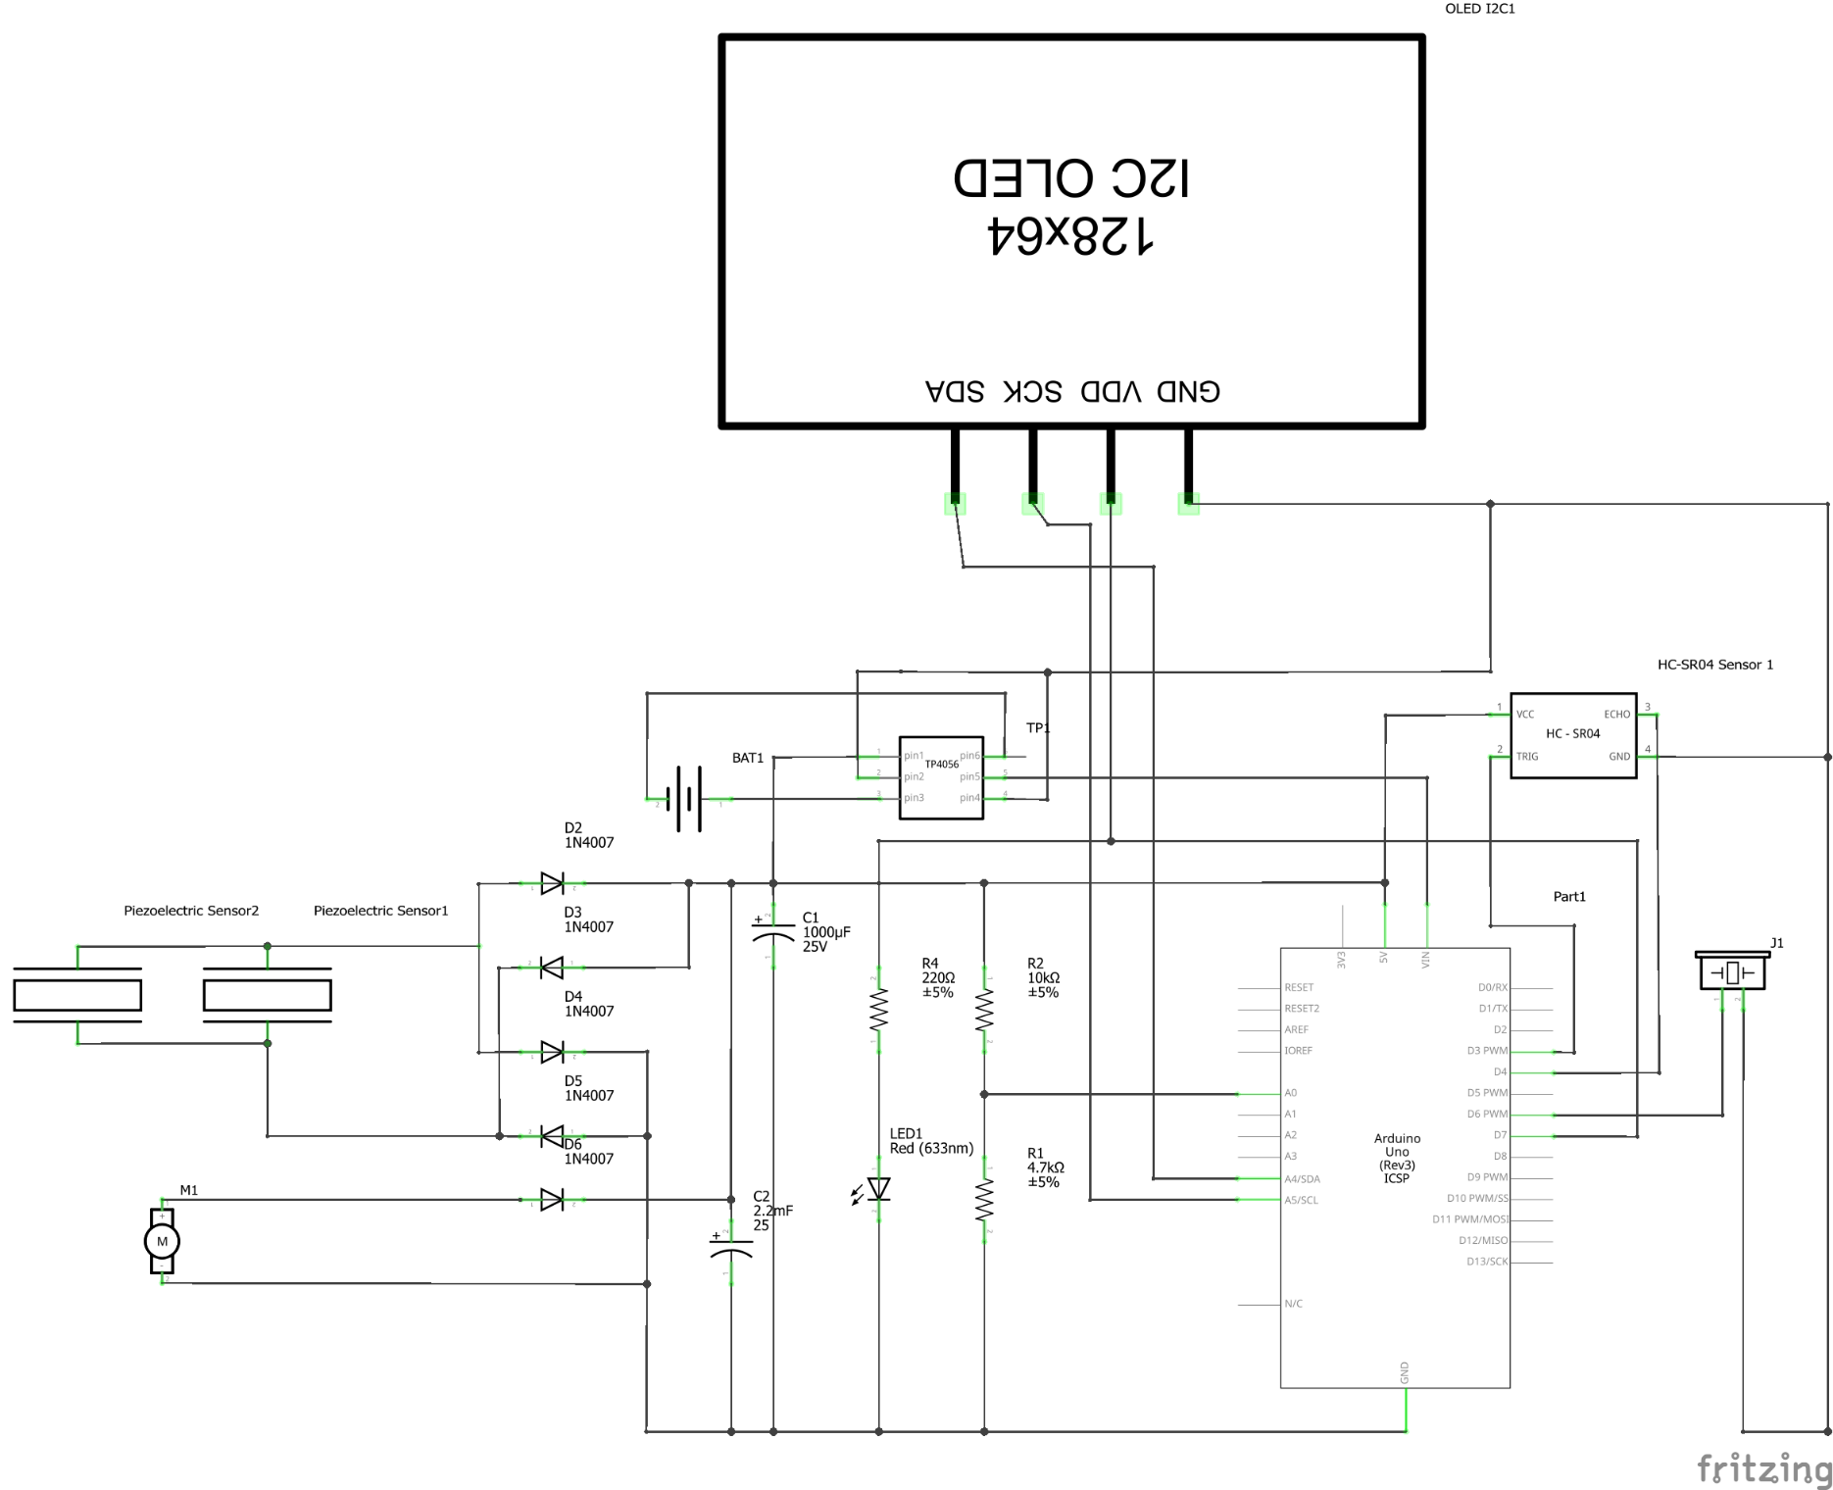
Fig 3.2: Circuit Diagram of Proposed System
1 | Arduino UNO R3 | 1
2 | ESP8266 (Wi-Fi Module) | 1
3 | Ultrasonic Sensor Module | 1
4 | OLED Display (0.96") | 1
5 | 9V Battery + Connector | 1
6 | Connecting Wires (Jumper Wires) | 1 Set
7 | Breadboard (Full/Half Size) | 2
8 | Vibration Motor | 2
9 | PVC Pipe 3 inch (Tunnel) | 1
10 | iezo Buzzer Elements | 6
11 | DC Motor (3V-6V) | 3
12 | IN4007 Diodes (Pack of 25) | 12
13 | Capacitor 1000µF, 25V | 2
14 | Capacitor 2200µF, 25V | 2
15 | Potentiometer 10kΩ | 1
16 | LED Assorted Pack (50 pcs) | 1
17 | Resistor Pack (100 pcs) | 1
18 | Active Buzzer (5V) | 1
19 | Red LED (10mm) | 2
20 | Toy Model | 1
21 | Lithium Battery | 1
22 | charging module | 1
Table 3.1 : Reference Numerals
- Detailed Explanation of Constructional Features:

The proposed hybrid energy harvesting system is constructed using multiple electromechanical and electronic components arranged systematically to capture, convert, store, and utilize energy generated from train-induced vibration and airflow inside railway tunnels.

1. Piezoelectric Energy Harvesting Module

Components Involved
- Piezoelectric Sensors (27–35 mm ceramic discs, 0.5–0.8 mm thickness)

Function

The piezoelectric sensors convert mechanical vibration energy into electrical energy using the piezoelectric effect. When subjected to pressure from train movement (20–50 Hz vibration), they generate alternating voltage.

Specifications (from report)
- Output voltage: 0.5V – 10V (AC)
- Capacitance: ~100 nF
- Piezoelectric coefficient: 200–400 pC/N

Association
- Multiple sensors (6–8 units recommended) connected in series to increase voltage output
- Output fed into bridge rectifier (Component 3)

Location

Mounted below or near railway tracks with rubber damping pads to prevent damage.

2. Airflow Energy Harvesting Module

Components
- DC Motor (6V, 3000–6000 RPM)
- Propeller (6–10 cm diameter)

Function

The motor acts as a generator, converting airflow caused by train movement into electrical energy.

Specifications
- Output voltage: 0.5V – 3V
- Current: 10–50 mA
- Efficiency: 30–50%

Association
- Connected to a bridge rectifier
- Output is smoothed by capacitor

Location

Installed inside tunnels where airflow is maximum.

3. Bridge Rectifier Module

Components
- 1N4007 Diodes (4 per rectifier)

Function

Converts AC voltage from piezo sensors and motor into DC voltage.

Specifications
- Forward voltage drop: 0.7V
- Current rating: 1A
- Reverse voltage: 1000V

Association
- Two bridge rectifiers:
  - One for piezo sensors
  - One for turbine generator

4. Smoothing Capacitor Module

Components
- 2200µF Capacitor
- 1000µF Capacitor

Function

Smoothens pulsating DC into stable DC by reducing ripple.

Specifications
- Voltage rating: 25V–35V
- Ripple reduction: from ~30–40% to <5%

Association

Connected across rectifier output terminals.

5. Diode Combination Module

Components
- 1N4007 Diodes (2 units)

Function

Combines outputs from piezo and motor sources while preventing reverse current flow.

Association
- Piezo DC → diode → hybrid node
- Motor DC → diode → hybrid node

6. Charging Module

Components
- TP4056 Lithium-ion Charging Module

Function

Charges battery using CC/CV (constant current/constant voltage) method.

Specifications
- Input: 4–8V
- Charge voltage: 4.2V
- Efficiency: 85–90%

Association
- IN+ ← hybrid node
- IN- ← ground
- B+/B- → battery
- OUT+/OUT- → system power

7. Energy Storage Module

Components
- 18650 Li-ion Battery (2000–2600 mAh)

Function

Stores harvested energy for continuous system operation.

Specifications
- Nominal voltage: 3.7V
- Full charge: 4.2V
- Cut-off: 2.5–3.0V

8. Voltage Monitoring Module

Components
- 10kΩ Resistor (R1)
- 4.7kΩ Resistor (R2)

Function

Steps down battery voltage for Arduino measurement.

Calculation

$$V_{out}=V_{in}×\frac{4.7k}{10k+4.7k}=V_{in}×0.32$$

Example:
- 4.2V → 1.34V
- 3.7V → 1.18V

9. Microcontroller Module

Components
- Arduino Uno

Function

Controls system operation, monitors voltage, and activates outputs.

10. Sensor Module

Components
- HC-SR04 Ultrasonic Sensor

Function

Detects train presence using ultrasonic waves.

Formula

$$Distance=\frac{Time×0.034}{2}$$

11. Display Module

Components
- OLED Display (128×64, I2C)

Function

Displays voltage, system status, and alerts.

12. Output Module

Components
- LEDs (white, red, green, yellow)
- Resistors (100Ω, 220Ω)
- Buzzer (5V active)
- Relay module

Function
- LED → tunnel lighting
- Buzzer → warning system
- Relay → switching control

13. Mechanical Support Components

Components
- Rubber pads (Shore A 60–70)
- Wooden base (50×40 cm)
- Mounting hardware

Function

Provides stability and protects sensors from mechanical damage.

Overall System Integration

The system operates sequentially:
- Train produces vibration and airflow
- Piezo sensors and turbine generate AC power
- Bridge rectifiers convert AC to DC
- Capacitors smooth voltage
- Diodes combine sources
- TP4056 charges battery
- Arduino monitors and controls system
- Outputs (LED, buzzer) are activated

Final Mandatory Statement

No chemical compositions, formulations, or biological materials are used in this system. The design is purely based on electromechanical energy conversion and embedded system control.

- Detailed Explanation of the Invention’s Software / Analytical Portion
- Arduino reads voltage via voltage divider
- Ultrasonic sensor detects train
- OLED displays status
- Logic:
  - If voltage > threshold → turn ON LED
  - If train detected → activate alarm

Chapter 4
- Step-by-Step Explanation of the Working of the Invention
The proposed hybrid energy harvesting system operates by converting train-induced vibration and airflow into electrical energy, storing it, and utilizing it for tunnel lighting and safety applications. The working of the system is explained step-by-step with reference to the constructional features and analytical model.

Step 1: Generation of Mechanical Energy
When a train passes through the tunnel:
- Vibration is produced on the track surface
- Airflow is generated due to train motion
Parameters
- Train speed: 60–120 km/h
- Train weight: 200–800 tons
These parameters directly influence energy generation.
Step 2: Vibration Energy Conversion (Piezo Module)
- Piezoelectric sensors (Component 1) experience pressure due to vibration
- Mechanical stress is converted into AC voltage
Threshold Values
- Minimum vibration frequency: ~20 Hz
- Output voltage range: 0.5V – 10V (AC)
- Effective operating force: >50 N
Output
AC electrical signal → sent to bridge rectifier (Component 3)

Step 3: Airflow Energy Conversion (Turbine Module)
- Airflow rotates turbine blades connected to DC motor (Component 2)
- Converts kinetic energy into electrical energy
Threshold Values
- Minimum airflow speed: ~2 m/s
- Output voltage: 1V – 5V (AC/DC)
Output
Electrical signal → fed into second bridge rectifier (Component 3)

Step 4: AC to DC Conversion
- Both piezo and motor outputs are converted to DC using bridge rectifiers (Component 3)
Loss Consideration
- Diode drop: ~0.7V per diode
Output
- Piezo DC output: 0.3V – 3V
- Motor DC output: 1V – 5V

Step 5: Voltage Smoothing (Capacitor Module)
- Capacitors (Component 4) smooth the pulsating DC signal
Parameters
- Capacitance: 1000µF – 2200µF
- Ripple reduction: <5%

Step 6: Hybrid Energy Combination
- Outputs from piezo and motor are combined using diodes (Component 5)
Function
- Prevents reverse current
- Ensures safe merging of sources
Output
$$V_{hybrid}=V_{piezo}+V_{motor}$$
Typical Range
- 2V – 5V DC

Step 7: Battery Charging (Charging Module)
- Hybrid output is fed into TP4056 (Component 6)
Threshold Values
- Input voltage: 4V – 8V
- Battery charging voltage: 4.2V max
Function
- Regulates charging using CC/CV method
- Stores energy in battery (Component 7)

Step 8: Voltage Monitoring (Software Integration)
- Voltage divider (Component 5) scales voltage for Arduino (Component 8)
Threshold Calculation
$$V_{out}=V_{in}×0.32$$
Example
- 4.2V → 1.34V (safe for Arduino)

Step 9: Microcontroller Processing
The Arduino processes system data based on programmed logic.
Software Logic (from simulation model)
- If voltage ≥ 3.3V → system active
- If voltage < 3V → low power mode
Sensor Input
- Ultrasonic sensor detects train presence

Step 10: Output Activation
Lighting System
- LED turns ON when sufficient energy is available
Threshold
- Minimum voltage: ≥ 3.3V
Alert System
- Buzzer activates when train is detected

Step 11: Continuous Operation Cycle
- Energy is continuously generated whenever a train passes
- Battery stores energy for later use
- System operates even during low generation periods

- Calculations:
    - Piezo Output
Assume:
- 1 piezo = 5V, 1mA
- 2 piezo → 5V, 2mA
Power:
$$P=V×I=5×0.002=0.01W$$
    - Motor Output
Assume:
- Motor = 6V, 50mA
$$P=6×0.05=0.3W$$
    - Total Power
$$P_{total}=0.01+0.3=0.31W$$

    - LED Requirement
1 LED:
$$P=2V×20mA=0.04W$$
5 LEDs:
$$P=0.2W$$
- Details of tests that have been conducted [to validate the Invention's efficiency/advantages], results obtained, and inferences. The testing to be done may depend on the advantages that are to be portrayed:
. Piezoelectric Energy Generation Test
Objective
To measure voltage generated from train-induced vibration (simulated using mechanical pressure).
Method
- Two piezoelectric sensors were connected in parallel
- External mechanical force was applied manually to simulate vibration
- Output voltage measured using a multimeter
Results
- Output voltage range: 0.5V – 4V (AC)
- After rectification: 0.3V – 3V (DC)
Inference
- Piezo sensors successfully convert vibration into electrical energy
- Output is low but consistent, suitable for low-power applications

2. Airflow Energy Generation Test (Motor Generator)
Objective
To evaluate energy generation from airflow using a DC motor as turbine.
Method
- Airflow created using fan / manual blowing
- Motor connected to bridge rectifier
- Output voltage measured
Results
- Output voltage: 1V – 5V (DC)
- Current: 10–50 mA

Inference
- Airflow energy provides higher power output than piezo sensors
- Effective in tunnel-like airflow conditions

3. Hybrid Energy Combination Test
Objective
To verify combined output from piezo and motor sources.
Method
- Both sources connected through diode combination circuit
- Output measured across capacitor
Results
- Combined voltage: 2V – 5V (DC)
- Improved stability compared to individual sources
Inference
- Hybrid system increases overall energy generation
- Ensures continuous power availability
4. Capacitor Charging Test
Objective
To check smoothing and temporary storage of energy.
Method
- Capacitor connected after rectifier
- Voltage rise observed over time
Results
- Ripple reduced significantly
- Voltage stabilized within 1–2 seconds
Inference
- Capacitor effectively smooths DC output
- Improves reliability of power supply
5. Battery Charging Test
Objective
To validate energy storage using TP4056 module.
Method
- Hybrid output connected to TP4056
- Battery voltage monitored
Results
- Battery voltage increased from 3.6V to 3.9V
- Charging observed under continuous input

Inference
- System successfully charges battery
- Suitable for energy storage applications
6. Arduino Voltage Monitoring Test
Objective
To verify voltage sensing and system control.
Method
- Voltage divider connected to Arduino A0
- Serial monitor used to observe readings
Results
- Accurate voltage readings obtained
- Real-time monitoring achieved
Inference
- System can monitor energy levels efficiently
- Enables smart control features
7. LED Lighting Test (Tunnel Simulation)
Objective
To validate practical application (tunnel lighting).
Method
- LED connected to Arduino output
- Activated when sufficient voltage detected
Results
- LED successfully turned ON
- Stable illumination observed
Inference
- System can power low-energy lighting
- Demonstrates real-world usability
8. Simulation Validation Test
Objective
To validate system performance under different train conditions using MATLAB simulation
Results
- Power output: ~50–200 mW
- Energy increases with:
  - Train speed (∝ speed¹·⁵)
  - Train weight (∝ √weight)

Inference
- Hybrid system significantly improves energy output
- Simulation supports real-time experimental results

Overall Inference
- The proposed system successfully harvests energy from both vibration and airflow
- Hybrid approach provides higher efficiency and reliability compared to single-source systems
- Energy generated is sufficient for low-power tunnel lighting and monitoring systems
- System is scalable and suitable for real-world railway applications

- Characterisation Tests, Comparative Results, and Inferences
Since the proposed system is an electromechanical energy harvesting system and does not involve any chemical compositions or formulations, the performance of the system is characterised through electrical output parameters, efficiency, and comparison with existing conventional systems

Output Voltage Characterisation
Test Conducted
Measurement of DC output voltage from individual and combined energy sources.
Source Type | Voltage Range (DC)
Piezo Sensors | 0.3V – 3V
Motor Generator | 1V – 5V
Hybrid Output | 2V – 5V
Table 4.1: Results
Inference: The hybrid system produces a higher and more stable voltage output compared to individual sources.

Chapter 5

- Examples that illustrate real-time functioning of the Invention, in different scenarios:
Scenario 1: Train Entering the Tunnel
When a train enters the tunnel, strong vibrations and airflow are generated.
Working:
- Piezoelectric sensors convert vibration into electrical energy
- Wind turbine generates energy from airflow
- Bridge rectifiers convert AC to DC
- Energy is stored in the battery
Result:
- Tunnel lighting (LEDs) turns ON automatically
- Visibility improves for locomotive pilot

- A list of all advantages of the Invention and how the Invention overcomes the drawbacks of the existing solutions:
1. Hybrid Energy Generation
Advantage:
The system combines piezoelectric vibration energy and airflow energy, increasing total power generation.
Overcomes Drawback:
Unlike footsteps-based or single-source systems, which produce low and inconsistent power, the hybrid approach ensures continuous and improved energy output.
2. Suitable for Railway Tunnel Environment
Advantage:
Designed specifically for train-induced vibration and airflow inside tunnels.
Overcomes Drawback:
Existing systems like footstep generators are not applicable in railway tunnels, whereas this system directly utilizes train movement conditions.

3. Self-Sustaining Power System
Advantage:
Generates electricity without external power sources.
Overcomes Drawback:
AI-based tunnel systems depend on external electricity supply, while this system reduces dependency and provides autonomous operation.
4. Cost-Effective Implementation
Advantage:
Uses low-cost components such as piezo sensors, diodes, and DC motors.
Overcomes Drawback:
Advanced multi-source systems are expensive and complex, whereas this system is simple and affordable for real-world deployment.
5. Energy Storage Capability
Advantage:
Incorporates battery storage using a charging module.
Overcomes Drawback:
Many existing systems lack efficient energy storage, leading to energy loss. This system ensures continuous power availability.
- Possible future enhancements to the invention, if any:
- IoT monitoring
- AI-based prediction
- Large-scale deployment
- Higher efficiency materials

Chapter 6
- Concluding Summary.
The proposed hybrid energy harvesting system effectively utilizes vibration and airflow energy to generate electricity in railway tunnels. The system improves safety, reduces power dependency, and promotes sustainable infrastructure.
References:
- A review of vibration energy harvesting in rail transportation field Author: Lingfei Qi , Hogye Pan , Yajia Pan , Dabing Luo , Jinyue Yan
Link: https://www.sciencedirect.com/science/article/pii/S2589004222001195
- Piezoelectric energy harvesting in railways: Current status and future challenges
Author: Dong Ding , Jiahe Fan , Haoyu Wang
Link: https://www.sciencedirect.com/science/article/pii/S2211467X25002329
- Vibration energy harvesting from railway tracks via a magnetic–piezoelectric system
Author: Peyman Aela, Hung-Lin Chi*, Yiwei Weng, Yangsheng Lin and David P Connolly
Link: https://iopscience.iop.org/article/10.1088/1361-665X/ae1d39
- Hybrid vibration and wind energy harvesting using combined piezoelectric and electromagnetic conversion for bridge health monitoring applications
Author: Muhammad Iqbal
Link:https://www.sciencedirect.com/science/article/abs/pii/S0196890418307805
- Piezoelectric energy harvesting in railways: Current status and future challenges
Author: Ding, Dong Fan, Jiahe ;Wang, Haoyu ;Jing, Guoqing ;Guo, Yunlong
Link: https://ui.adsabs.harvard.edu/abs/2025EneSR..6101869D/abstract#:~:text=Pie zoelectric%20energy%20harvesting%2C%20which%20converts,design%2C%20a nd%20ease%20of%20integration.
- A wind-solar energy harvester based on airflow enhancement mechanism for
rail-side devices
Author: Hao Wang, Minyi Yi, Zutao Zhang
Link:https://www.sciencedirect.com/science/article/abs/pii/S0360544223025100
- Energy harvesting technologies on high-speed railway infrastructure: Review and comparative analysis of the potential and practicality
Author: Wenjing Sun
Link: https://www.sciencedirect.com/science/article/pii/S2213138825000189
- Design optimisation of piezoelectric energy harvesters for bridge infrastructure
Author: P. Peralta-Braz, M.M. Alamdari , R.O. Ruiz , E. Atroshchenko
Link: https://www.sciencedirect.com/science/article/pii/S0888327023007318
- Piezoelectric Energy Harvesting: A Systematic Review of Reviews Author: Mohammad Mostafa Mohammadi, Jafar Ghazanfarian
Link: https://www.mdpi.com/2076-0825/10/12/312

Note:
- For mechanical inventions, mention the location of each component, explain the function of each component, and also include how the components are associated with one another. Innovative units/modules, and components that have been specially configured, such as frames, can be explained with separate Figures. In the explanation, please also include important dimensions.

- For electromechanical inventions, please include the sensor type, its configuration, and its thresholds [drawings of the circuitry are required, along with a detailed explanation].

- For compositions or formulations, include a list of ingredients, the function of each ingredient, the percentage range of each ingredient, and the process by which the composition is prepared.

- For software inventions, include at least one high level system drawing with tangible hardware (mobile phone, computer, etc.), in addition to listing all the modules and their functionalities. Method of functioning is to be explained, in a real-world scenario i.e. once input parameters are fed, what processing occurs, how does the processing occur, and what output is provided.

